Issue 1:

SELECT SRC1.App_Owner_Validity_Flag,SRC1.user_name,TRGT.app_owner_validity_flag_c,COUNT(1) as CNT

FROM png_mdsdb.pg_mega_pgb_application_rita_final SRC

LEFT JOIN

(

SELECT ASSET_OWNER.app_hexid,ASSET_OWNER.sourceinstance,Employee_Type,CASE WHEN USR.user_name IS NOT NULL THEN 'Y' ELSE 'N' END AS App_Owner_Validity_Flag,user_name

FROM

(

SELECT a.app_hexid,a.sourceinstance,

CASE WHEN COUNT(distinct a.person_hex) <= 1 THEN COALESCE(MAX(a.person_hex),'UNSPECIFIED') ELSE 'UNKNOWN' END AS 'person_hex',

CASE WHEN COUNT(distinct a.person_hex) <= 1 THEN COALESCE(MAX(a.person_intranet_id),'UNSPECIFIED') ELSE 'UNKNOWN' END AS 'person_intranet_id'

FROM png_mdsdb.pg_mega_pgv_app_responsible_org_person_final a WHERE a.application_manager = 'Y' AND a.cdctype<>'D'

group by a.app_hexid,a.sourceinstance

) ASSET_OWNER

LEFT JOIN

(Select user_name,MAX(u_employee_type) AS Employee_Type

FROM png_mdsdb.sys_user_final where user_name IS NOT NULL AND u_employee_type='Employee' AND active =1 AND cdctype<>'D' group by 1) USR

ON ASSET_OWNER.person_intranet_id=USR.user_name

) SRC1 ON SRC.NAME=SRC1.app_hexid AND SRC.sourceinstance=SRC1.sourceinstance

LEFT JOIN png_mdwdb.d_rita_application_ext_c TRGT ON SRC.NAME=TRGT.row_id AND SRC.sourceinstance=TRGT.source_id

WHERE SRC1.App_Owner_Validity_Flag<>TRGT.app_owner_validity_flag_c

AND SRC.cdctype<>'D'

group by 1;

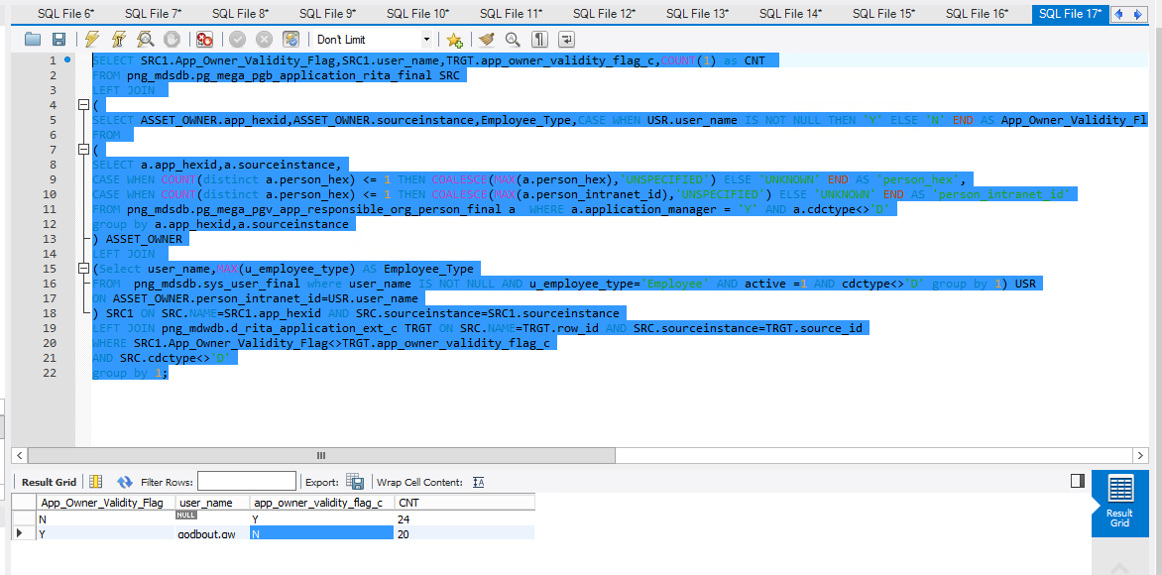

Issue 2:

SELECT COALESCE(SRC1.DB_NAME,'UNSPECIFIED'),TRGT.db_name_c,Count(1) AS CNT

FROM png_mdsdb.pg_mega_pgb_application_rita_final SRC

LEFT JOIN

(

SELECT APP_HEX,sourceinstance,GROUP_CONCAT(distinct DB_NAME ORDER BY DB_NAME) AS DB_NAME

FROM png_mdsdb.pg_mega_snv_app_hierarchy_final where APP_HEX IS NOT NULL and cdctype<>'D'

group by 1,2

) SRC1 ON SRC.NAME=SRC1.APP_HEX AND SRC.sourceinstance=SRC1.sourceinstance

LEFT JOIN png_mdwdb.d_rita_application_ext_c TRGT ON SRC.NAME=TRGT.row_id AND SRC.sourceinstance=TRGT.source_id

WHERE COALESCE(SRC1.DB_NAME,'UNSPECIFIED')<>TRGT.db_name_c

AND SRC.cdctype<>'D'

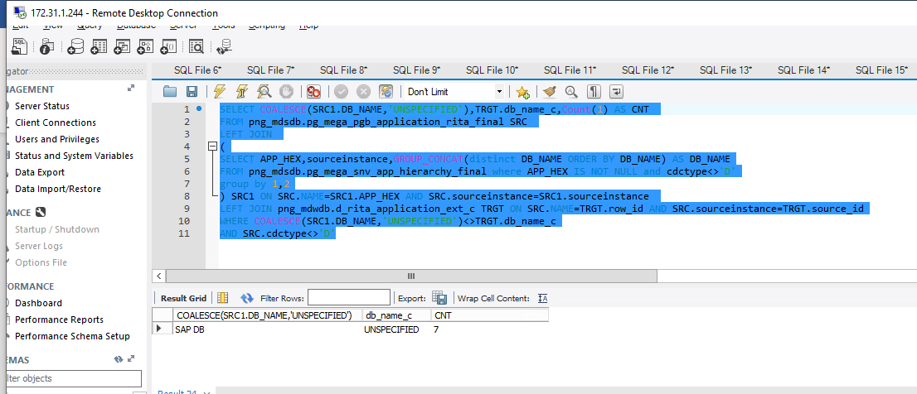

Issue 3:

SELECT COALESCE(SRC1.SERVER_NAME,'UNSPECIFIED'),TRGT.server_name_c, Count(1) AS CNT

FROM png_mdsdb.pg_mega_pgb_application_rita_final SRC

LEFT JOIN

(

SELECT APP_HEX,sourceinstance,GROUP_CONCAT(distinct SERVER_NAME ORDER BY DB_NAME) AS SERVER_NAME

FROM png_mdsdb.pg_mega_snv_app_hierarchy_final where APP_HEX IS NOT NULL and cdctype<>'D'

group by 1,2

) SRC1 ON SRC.NAME=SRC1.APP_HEX AND SRC.sourceinstance=SRC1.sourceinstance

LEFT JOIN png_mdwdb.d_rita_application_ext_c TRGT ON SRC.NAME=TRGT.row_id AND SRC.sourceinstance=TRGT.source_id

WHERE COALESCE(SRC1.SERVER_NAME,'UNSPECIFIED')<>TRGT.server_name_c

AND SRC.cdctype<>'D'

group by 1;

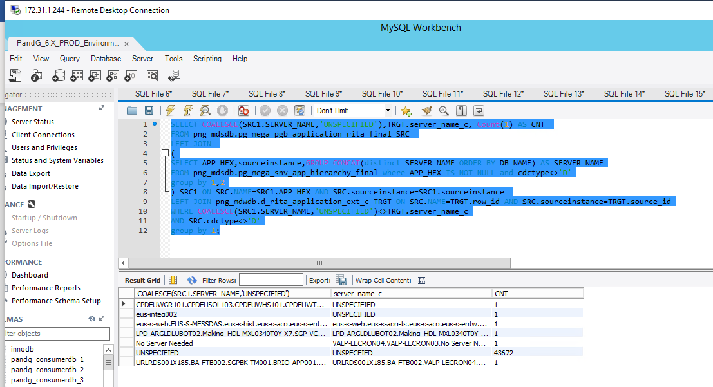

Issue 4:

SELECT COALESCE(SRC1.RELEASE_NAME,'UNSPECIFIED'),TRGT.release_name_c,Count(1) AS CNT

FROM png_mdsdb.pg_mega_pgb_application_rita_final SRC

LEFT JOIN

(

SELECT APP_HEX,sourceinstance,GROUP_CONCAT(distinct RELEASE_NAME ORDER BY DB_NAME) AS RELEASE_NAME

FROM png_mdsdb.pg_mega_snv_app_hierarchy_final where APP_HEX IS NOT NULL and cdctype<>'D'

group by 1,2

) SRC1 ON SRC.NAME=SRC1.APP_HEX AND SRC.sourceinstance=SRC1.sourceinstance

LEFT JOIN png_mdwdb.d_rita_application_ext_c TRGT ON SRC.NAME=TRGT.row_id AND SRC.sourceinstance=TRGT.source_id

WHERE COALESCE(SRC1.RELEASE_NAME,'UNSPECIFIED')<>TRGT.release_name_c

AND SRC.cdctype<>'D'

group by 1;

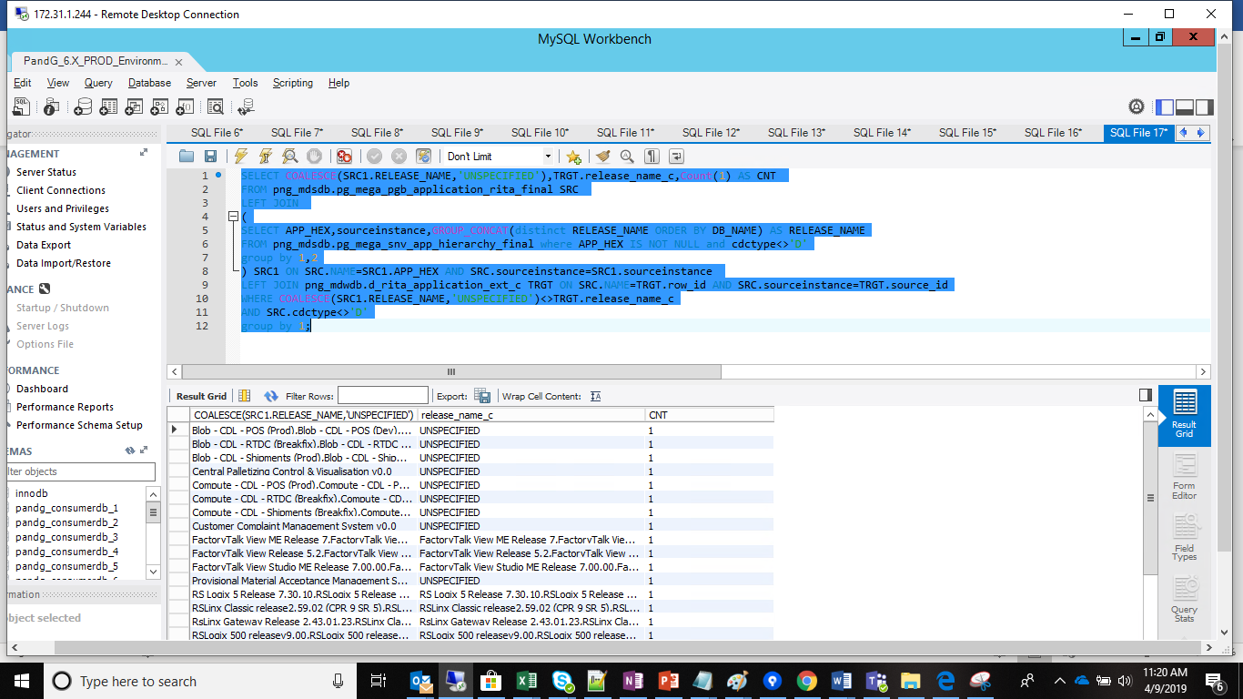

Issue 5:

SELECT COALESCE(SRC1.INSTANCE_NAME,'UNSPECIFIED'),TRGT.instance_name_c,Count(1) AS CNT

FROM png_mdsdb.pg_mega_pgb_application_rita_final SRC

LEFT JOIN

(

SELECT APP_HEX,sourceinstance,GROUP_CONCAT(distinct INSTANCE_NAME ORDER BY DB_NAME) AS INSTANCE_NAME

FROM png_mdsdb.pg_mega_snv_app_hierarchy_final where APP_HEX IS NOT NULL and cdctype<>'D'

group by 1,2

) SRC1 ON SRC.NAME=SRC1.APP_HEX AND SRC.sourceinstance=SRC1.sourceinstance

LEFT JOIN png_mdwdb.d_rita_application_ext_c TRGT ON SRC.NAME=TRGT.row_id AND SRC.sourceinstance=TRGT.source_id

WHERE COALESCE(SRC1.INSTANCE_NAME,'UNSPECIFIED')<>TRGT.instance_name_c

AND SRC.cdctype<>'D'

group by 1;

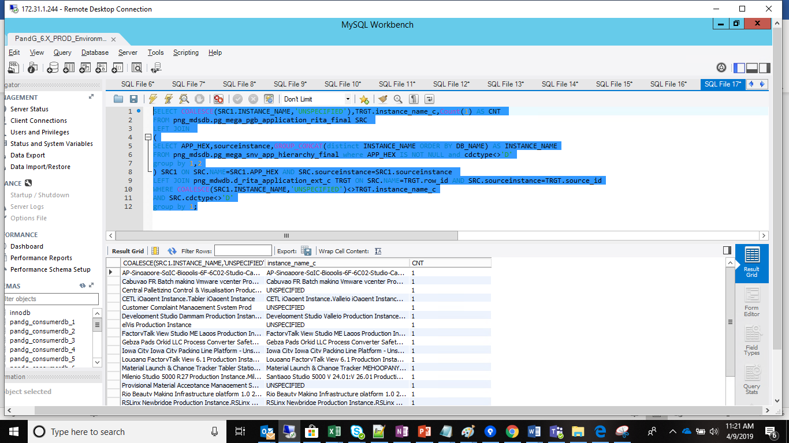

Issue 6:

SELECT COALESCE(lead_solution_architect,'UNSPECIFIED'),TRGT.lead_solution_architect_c,

Count(1) as CNT

FROM png_mdsdb.pg_mega_pgb_application_rita_final SRC

LEFT JOIN

(

SELECT a.app_hexid,a.sourceinstance,

GROUP_CONCAT(distinct person_intranet_id) AS lead_solution_architect

FROM png_mdsdb.pg_mega_pgv_app_responsible_org_person_final a WHERE

(a.pg_architect IS NOT NULL AND a.pg_architect <> ' ' AND a.pg_architect <> 'N') AND cdctype<>'D'

group by a.app_hexid

) Lead_Sol_Arcitect ON SRC.NAME=Lead_Sol_Arcitect.app_hexid AND SRC.sourceinstance=Lead_Sol_Arcitect.sourceinstance

LEFT JOIN png_mdwdb.d_rita_application_ext_c TRGT ON SRC.NAME=TRGT.row_id AND SRC.sourceinstance=TRGT.source_id AND SRC.cdctype<>'D'

WHERE COALESCE(lead_solution_architect,'UNSPECIFIED')<>TRGT.lead_solution_architect_c

AND SRC.cdctype<>'D'

group by 1;

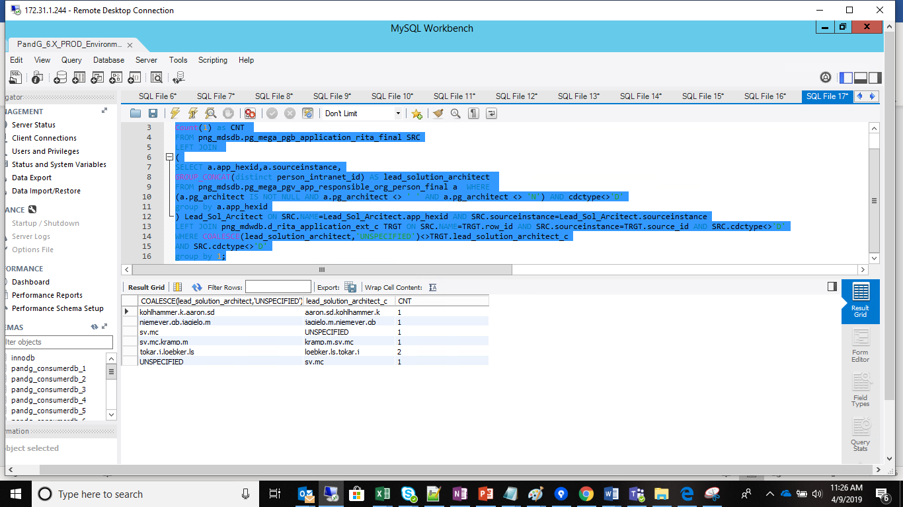

Issue 7:

SELECT COALESCE(SRC1.Keyword_Subject_Area,'UNSPECIFIED'),TRGT.keyword_subject_area_c,Count(1) as CNT

FROM png_mdsdb.pg_mega_pgb_application_rita_final SRC

LEFT JOIN

(Select APP_HEXID,sourceinstance,GROUP_CONCAT(DISTINCT KEYWORD_NAME ORDER BY KEYWORD_ID) AS Keyword_Subject_Area

FROM png_mdsdb.pg_mega_pgb_app_keyword_final where APP_HEXID IS NOT NULL AND KEYWORD_ID IS NOT NULL and KEYWORD_ID<>'' AND cdctype<>'D'

group by 1,2) SRC1 ON SRC.NAME=SRC1.APP_HEXID AND SRC.sourceinstance=SRC1.sourceinstance

LEFT JOIN png_mdwdb.d_rita_application_ext_c TRGT ON SRC.NAME=TRGT.row_id AND SRC.sourceinstance=TRGT.source_id

WHERE COALESCE(SRC1.Keyword_Subject_Area,'UNSPECIFIED')<>TRGT.keyword_subject_area_c

AND SRC.cdctype<>'D'

group by 1;

